Veterinary consent form

One of your clients has requested physiotherapy treatment for their horse/dog. To indicate consent please complete the following form and email/paper copy to return. I can be contacted on the number or email above if you wish to discuss the case. Thank you.

Owner’s Details

|  |  |
| --- | --- |
| Name: |  |
| Address: |  |
| Telephone: |  |
| Email: |  |

Animal’s Details

|  |  |  |  |
| --- | --- | --- | --- |
| Name: |  | | |
| Age: |  | Sex: |  |
| Breed: |  | Colour: |  |

I declare I am the legal owner of the named animal above and to the best of my knowledge all the information provided is correct. I give consent for Gina Cook to treat my animal with physiotherapy and to discuss details of treatment with my veterinary surgeon.

Owner Signature: …… ………… Print Name:… …… ………………... Date:

**Your veterinary surgeon should complete the sections below and sign.**

Medical History

I consent to this animal to have physiotherapy treatment, including the use of electrotherapies when appropriate. I understand that the provision of professional indemnity insurance for this is the responsibility of Gina Cook.

|  |  |  |  |
| --- | --- | --- | --- |
| Practice:  Name & Address |  | | |
| Telephone: |  | | |
| Email: |  | | |
| Vets Name (print): |  | | |
| Vets Signature: |  | Date: |  |

**Please tick:**

I would like a follow up report from every session: [ ] Follow up report at every 3/6 session (unless a problem was found): [ ]

Gina Cook

BSc Veterinary physiotherapist

16 Rufford Close Guisborough,

TS147PU

Email: ginacook1997@live.com

07964810075

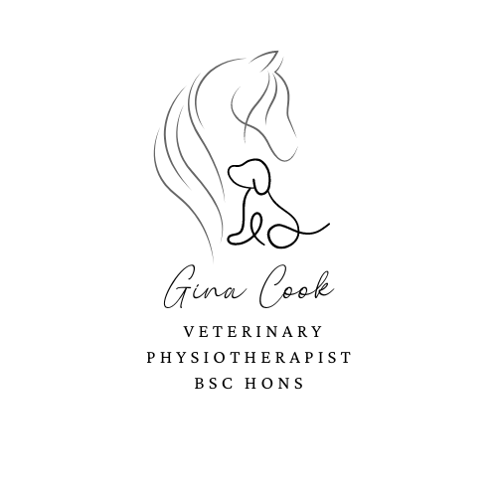

DETAILS OF PRESENT HEALTH CONDITION(s) AND VETERINARY MANAGEMENT

Covering the Northeast of England

Qualified in Veterinary Physiotherapy BSc

Qualified in Therapeutic Massage for Animals

Registered with IRVAP

Fully Insured.

.